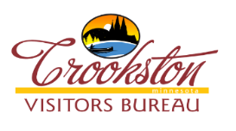 Event Marketing Sponsorship Post Event Evaluation

Event Name: _________________________________________________________________________

Event Date (s) ________________________________________________________________________

Event total attendance ________________________________________________________________

Event attendance per day (if trackable) ___________________________________________________

Actual % of tourists at event (if trackable) _________________________________________________

Actual hotel rooms booked due to the event _______________________________________________

Please describe the methodology used to determine the answers above (i.e. paid gate/ wristbands)

_____________________________________________________________________________________

_____________________________________________________________________________________

Actual Revenue: $ ____________________________________________________________________

Actual Expenses: $ ___________________________________________________________________

Do you plan to hold this event annually? _________________________________________________

Requested reimbursement amount: $ ___________________________________________________

Please attach the following information to this evaluation report:

- Marketing receipts showing how much was spent and where
- Tear sheets showing the actual advertisement, poster, mailing, etc.

*Incomplete reports will not be considered for reimbursement

*Reports will be accepted up to 60 days following the event

Evaluation forms may be submitted the following ways: Mail to: Crookston Visitors Bureau PO Box 312 Crookston MN 56716 or e-mail crookstoncvb@gmail.com

